- Estimating the density of grasshoppers in a school garden can be achieved through a mark-release-recapture experiment. The essay should be structured as follows:

Materials
- A large net or sweep net for catching grasshoppers.
- Non-toxic, visible marking paint or small tags.
- Release containers.
- Quadrats or measuring tapes to define sampling areas.
- Data recording sheets.
- Calculator.

Procedure:
1. Divide the school garden into several equal-sized plots or use quadrats to define sampling areas.
2. Capture grasshoppers from the selected plots using the sweep net for a fixed time period (e.g., 10 minutes).
3. Count the number of grasshoppers caught and mark each with a unique, non-toxic mark (e.g., paint spot).
4. Release the marked grasshoppers back into the same plots.
5. After a suitable time interval (e.g., 24 hours), recapture grasshoppers from the same plots again for the same duration.
6. Count the total number of grasshoppers in the second catch and note how many are marked.
7. Calculate density by dividing the population estimate by the area of the plots.

Expected Results: The experiment should yield an estimate of the number of grasshoppers per unit area (e.g., per square meter). The accuracy depends on assumptions such as random mixing of marked individuals and no significant immigration/emigration.
Conclusion: The mark-release-recapture method provides a practical way to estimate grasshopper density in the school garden, giving insight into the ecosystem's insect population. The results can be used to discuss ecological factors affecting grasshopper distribution and abundance.

- Experiment to investigate the effect of unequal distribution of light on a growing shoot:*
procedure
1. Select two identical young seedlings (e.g., bean or pea plants) with straight shoots.
2. Place both seedlings in identical pots with the same soil and water conditions.
3. Set up a light source (e.g., LED lamp) so that one side of one seedling receives direct light while the other side is shaded (unequal light distribution). Use a black cover or partition to block light on one side.
4. Leave the second seedling under uniform full light as a control.
5. Measure and record the initial shoot length and direction of growth for both seedlings.
6. Allow the plants to grow for a set period (e.g., 7–10 days), maintaining the same light conditions and watering regularly.
7. At the end of the period, measure the final shoot length, observe the direction of growth (bending), and compare the shoots of the two seedlings.
Expected results:
- The shoot exposed to unequal light will bend toward the light source (phototropism), showing uneven elongation on the shaded side compared to the illuminated side.
- The shoot under uniform light will grow straight with balanced elongation.
- The unequally lit shoot may have a longer overall length or faster growth on the light-exposed side.
Conclusion:
Unequal distribution of light causes a growing shoot to bend toward the light due to phototropic response, where auxins accumulate on the shaded side promoting cell elongation. This demonstrates that light influences shoot orientation and growth patterns, optimizing the plant’s ability to capture light for photosynthesis.

- a.
- Mango
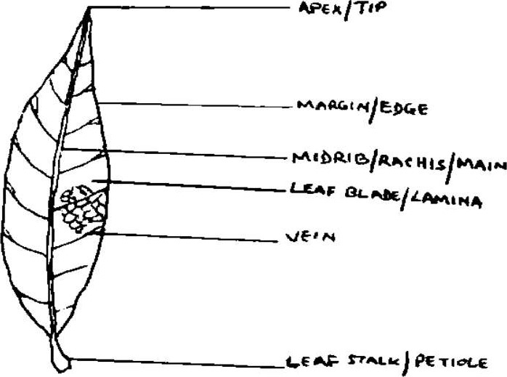
- leaf and grass
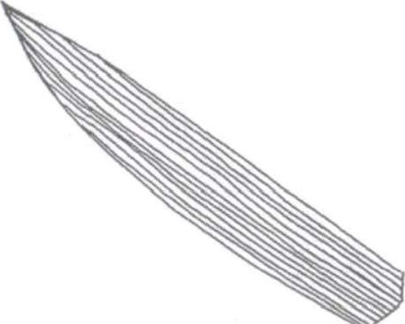

- Draw and label any three parts



4. Construct dichotomous key 8 marks
- Has legs .See 2
Has no legs.... . . . . .Herring
- Has tail.... . . . . .See 3

Has no tail.... . . . . . . . . . . . see 4
- Has visible ears. Wolf
Has no visible ears.. ... Lizard
- Has beak...Pigeon
Has no beak.. Frog
b. adaptation of pigeon
- lightweight, fused bones – which reduce overall body weight, making flight more efficient
- strong pectoral muscles- they possess large, powerful pectoral muscles, which enable vigorous wing movement needed for flying.
Suggested tips on how to mark biology in general.
- Theory part
- Answer should be brief and straight forward
- Dependent questions – once a candidate fail the key question automatically fail the dependent question
- Descriptions question – if it is the process then sequential order of facts is important and the number of marks determine the number of points(facts)
Essays
- Points should be straight to the points with their supporting points
- Paragraphing
- No numbering
- No bulletins
- No headings
- No diagram unless specified
- Students should avoid the word avoid in the answer when asked to explain ways of preventing certain diseases.

